
Product description

product description

产品概述

POE (PowerOverEthernet) means that without any changes to the infrastructure of CAT5 or CAT6 network wiring, it provides electrical transmission functions while transmitting signals for IP-based terminals. POE power supply is to provide power through the Ethernet interface connected to the cable. The way only relies on the network cable connected to the communication terminal to complete the power supply for them. This series of POE provides 48V voltage, and the transmission distance of AI smart selection power supply is as long as 100/250m. Using high-performance Ethernet switching main chip and PSE power supply chip combined with fast Ethernet transmission data signal and power supply function, and intelligent Ethernet POE power supply with AI intelligent management function, never burn the machine; with high backplane and capacity design, It has extremely fast data processing capabilities and smooth transmission of high-definition network data. Seiko steel alloy body electrostatic paint, promote dual-flow heat dissipation, stable performance and trouble-free work ≥ 30,000 hours; excellent port performance, simple installation. Support port fully loaded with IEEE802 3af/at standard power supply; 100M POE power supply: 12+/36- (data synchronous transmission); Gigabit POE line data: 12+/36-, power supply 45+/78; Managed POE switch supports SNMP protocol, WEB and other network management system platforms, easy to operate configuration switches and POE related parameter functions, provide safe transmission guarantee for video surveillance and network communication.
Smart POE power supply

When deploying PSE power supply equipment in a network, the working process of POE Power over Ethernet:
1. Detection: The wired PSE device outputs a very small voltage at the port until it detects that the connection of the cable terminal is a PD powered device that supports the IEEE802E3af standard;
2. PD device classification: After detecting the power receiving device PD, the PSE device may classify the PD device and evaluate the power loss required
by the PD device;
-1-
3. Start power supply: During the startup period of a configurable time (generally less than 15us), the PSE device starts to supply power to the PD device from a low voltage until it provides a 48V DC power supply;
Product features产品概述

1. Support full port IEEE802.3af/at standard
2. Transmit Ethernet data through a network cable and provide power supply function;
3. It can automatically detect and identify PD power receiving equipment that
meets the IEEE802.3af/IEEE802.3at standard;
4. Support port power supply priority to ensure continuous power supply at network gateways;
5. It has a short-circuit protection function. When the current is too large or the PD device fails, the power supply will be stopped to protect the PD powered device;
6. It comes with energy-saving and environmental protection, supports automatic standby mode and cable length and other functions, that is, automatically standby to save energy when the port is not connected. When the cable length is less than 10 meters, it provides the power transmission rate;
7. Support SNMP protocol, WEB management, flexible configuration of switch related parameter functions;
8.Full-series product line: 1-24 POE power supply port selection, 1-2 uplink electrical ports and SFP optical port cascade applications;

-2-

Product parameter

产品概述

Product panel diagram | 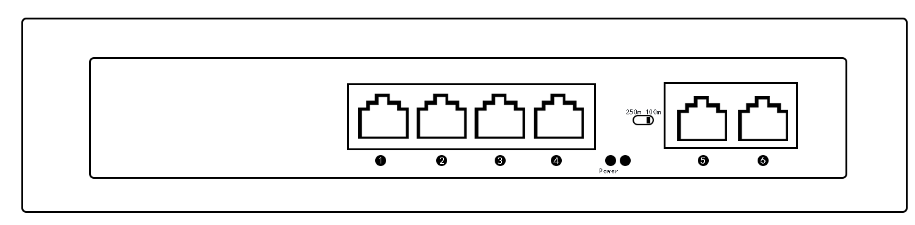 | 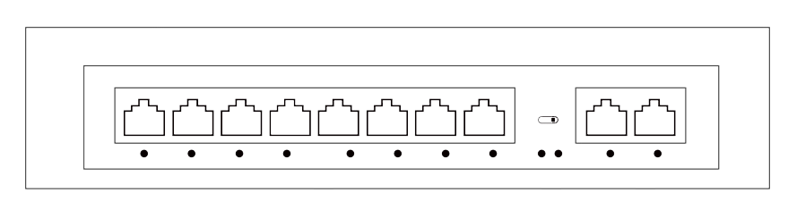
product name | 6 ports 100M POE switch | 10 ports 100M POE switch
UPLINK | 2*10/100Mbps ethernet ports
POE Port | 1-4 | 1-8
POE Distance | 100m or 250m（DIP switch settings）
Power supply pin | 1 2 +/3 6-
data transmission | 1 2 +/3 6-
Singl port power | 15.4W(16W)/25.5W(30W)
Total power | 65W | 120W
voltage range | AC220V / DC52V
Work Tempreature | -20℃~65℃
size | 202*140*45mm Internal power supply（3代）
Product panel diagram | 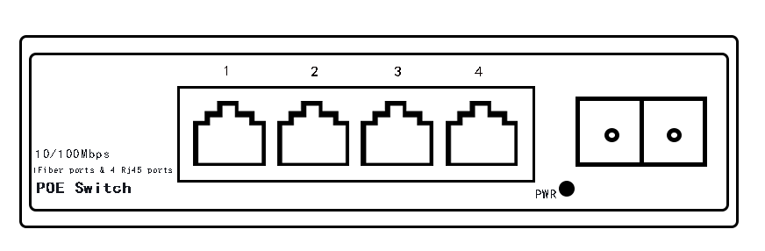 | 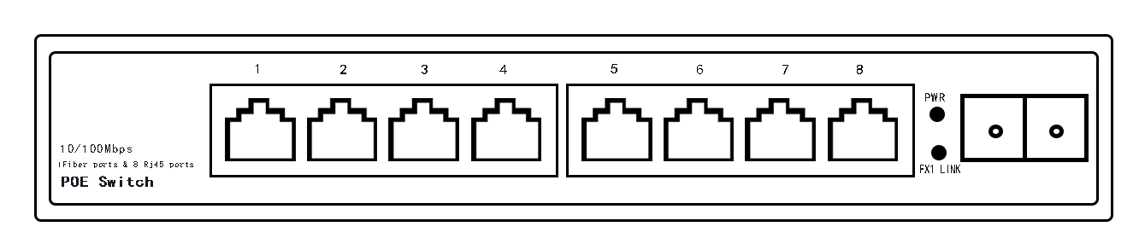
product name | 1*Fiber +4*Ethernet 100M POE switch | 10/100M 1*Fiber+8*POE ports POE switch
UPLINK | 1*155M fiber port（SC/FC/ST）
POE Port | 1-4 | 1-8
POE Distance | 100m
Power supply pin | 1 2 +/3 6-
data transmission | 1 2 +/3 6-
Singl port power | 15.4W(16W)/25.5W(30W)
Total power | 65W | 120W
voltage range | AC220V / DC52V
Work Tempreature | -20℃~65℃
size | 134*84*28mm Internal power supplyAC220V | 200*104*28mm Internal power supplyAC220V
-3-
Product panel diagram | 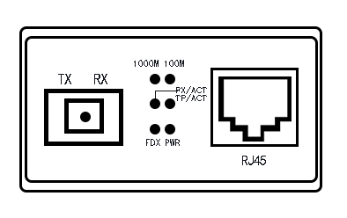 |  | 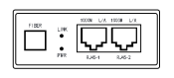 |  | 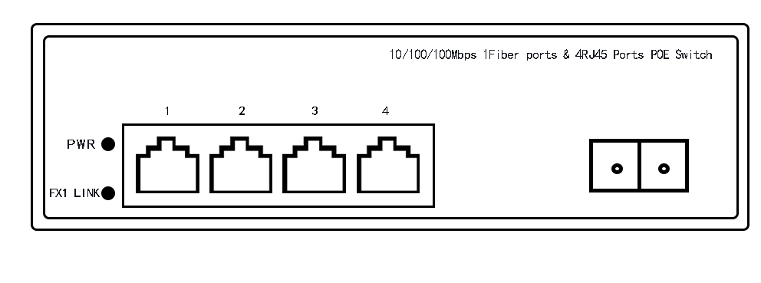
product name | 1000M 1*Fiber +1*POE port POE Switch |  | 1000M 1*Fiber+2*POE ports POE Switch |  | 1000M 1*Fiber+4*POE ports POE Switch
UPLINK | 1*1.25G fiber port
POE Port | 1 | 1-2 |  |  | 1-4
POE Distance | 100m
Power supply pin | 4 5 +/7 8-
data transmission | 1 2 +/3 6-
Singl port power | 15.4W(16W)/25.5W(30W)
Total power | 65W
voltage range | AC220V / DC52V
Work Tempreature | -20℃~65℃
size | 95*70*28mm External power supply |  |  | 118*88*28mm External power supply | 152*87*44mm External power supply
Product panel diagram | 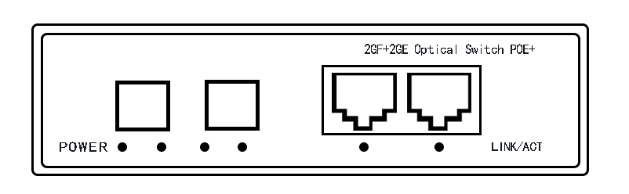 |  | 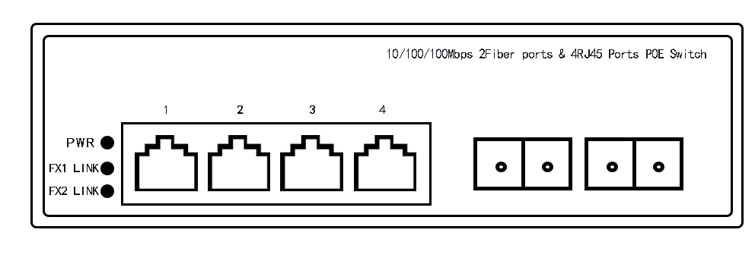
product name | 1000M 2*Fiber +2*POE port POE Switch |  | 1000M 2*fiber +4*POE ports POE switch
UPLINK | 2*1.25G fiber ports
POE Port | 1-2 | 1-4
POE distance | 100m
Power supply pin | 4 5 +/7 8-
data transmission | 1 2 +/3 6-
Singl port power | 15.4W(16W)/25.5W(30W)
Total power | 65W
voltage range | AC220V / DC52V
Work Tempreature | -20℃~65℃
size | 134*91*28mm External power supplyAC220V |  |  | 152*87*44mm External power supplyAC220V
-4-
Product panel diagram | 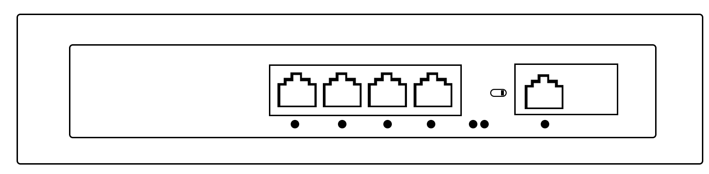 | 
product name | 5 ports POE Switch | 10 ports POE Switch
UPLINK | 100M:1*10/100Mbps RJ45 Port | 100M:2*10/100Mbps RJ45 Port
UPLINK | 1000M:1*10/100/1000Mbps RJ45 Port | 1000M:2*10/100/1000Mbps RJ45 Port
Product panel diagram | 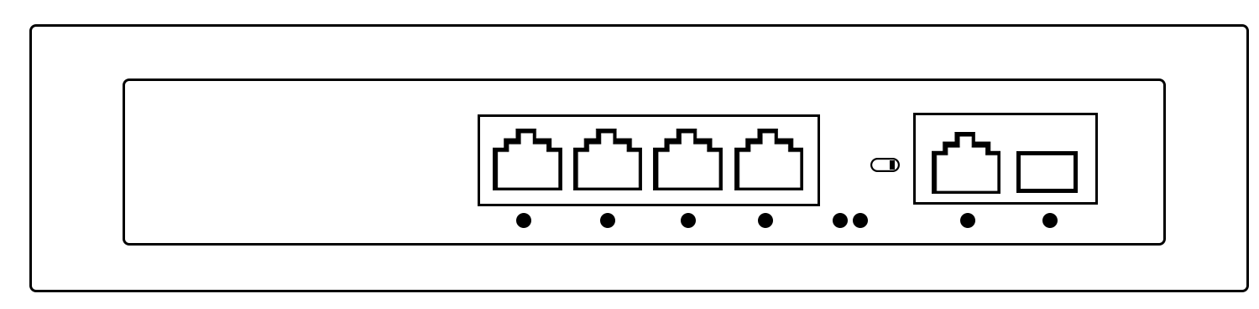 | 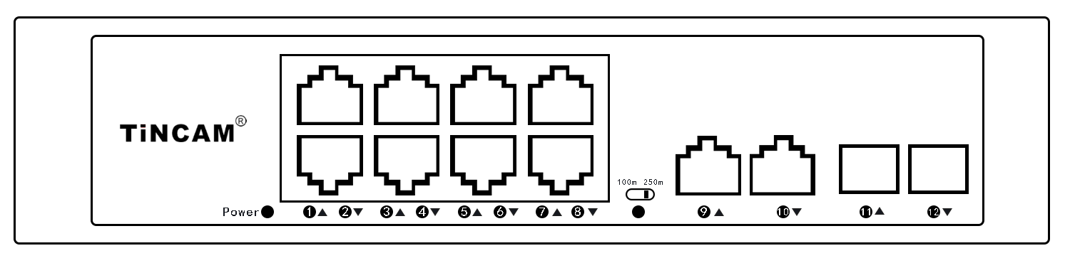
product name | 6 ports POE Switch | 12 ports POE Switch
UPLINK | 1*10/100/1000Mbps RJ45 Port+1*1.25G SFP fiber ports | 2*10/100/1000Mbps RJ45 Ports +2*1.25G SFP fiber ports
POE Port | 1-4 | 1-8
POE distance | DIP switch setting function: 1. Reset; 2. Transmission 100 meters or 250 meters
Power supply pin | 100M:1 2 +/3 6-
Power supply pin | 1000M:4 5+/7 8-
data transmission | 1 2 +/3 6-
Singl port power | 15.4W(16W)/25.5W(30W)
Total power | 65W | 120W
voltage range | AC220V / DC52V
Work Tempreature | -20℃~65℃
size | 202*140*45mm | 220*160*45mm
-5-
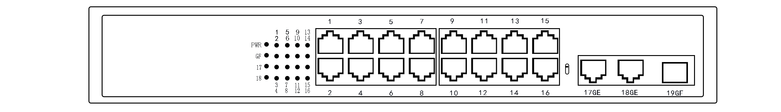Product panel diagram | 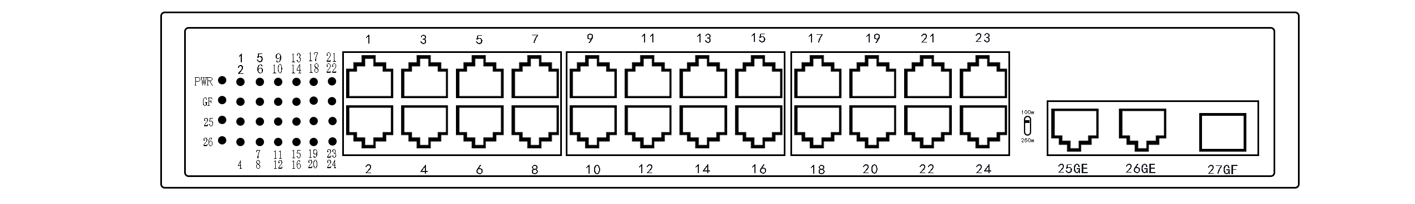
product name | 1000M 19 ports POE switch | 1000M 27 ports POE switch
Total power | 200W | 200W 260W
UPLINK | 2*10/100/1000Mbps Ethernet ports+1*1.25G SFP Fiber Port
POE Port | 1-16 | 1-24
POE distance | 100m or 250m （DIP switch settings）
Singl port power | 15.4W(16W)/25.5W(30W)
Power supply pin | 1 2 +/3 6-
data transmission | 1 2 +/3 6-
voltage range | AC220V / DC52V
Work Tempreature | -20℃~65℃
size | 310*182*45mm Internal power supplyAC220V
Product panel diagram | 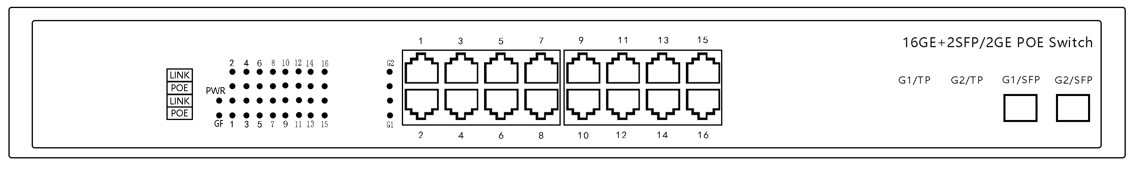 | 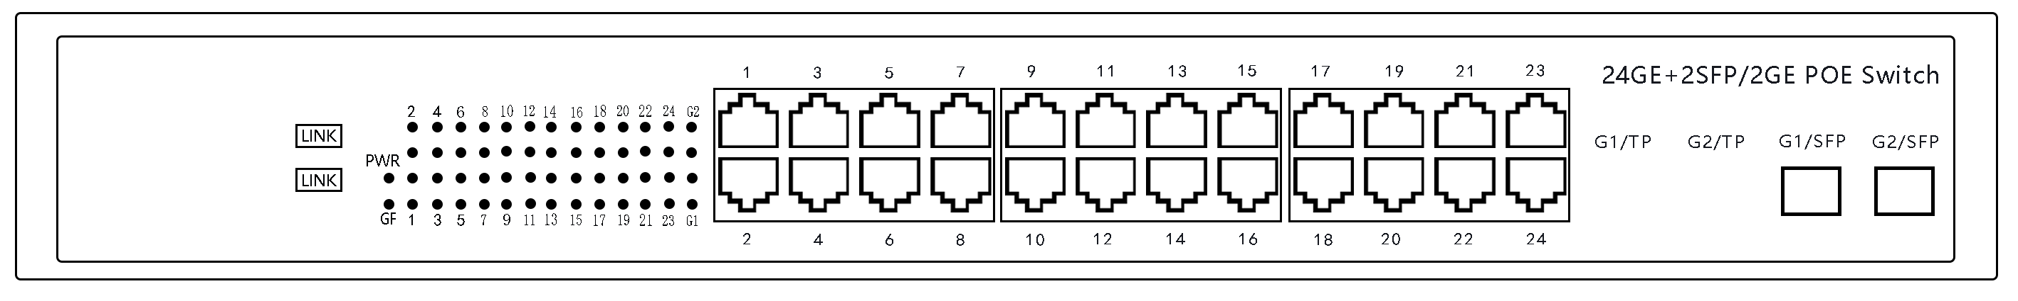
product name | Full 1000M 18 ports POE switch | Full 1000M 26 ports POE switch
Total power | 250W | 250W 450W
UPLINK | 2*1.25G SFP fiber port
POE Port | 1-16 | 1-24
POEdistance | 100m
Singl port power | 15.4W(16W)/25.5W(30W)
Power supply pin | 4 5 +/7 8-
data transmission | 1 2 +/3 6-
voltage range | AC220V / DC52V
Tempreature | -20℃~65℃
size | 430*295*45mm（1U Rack type）
-6-
-7-
Product panel diagram | 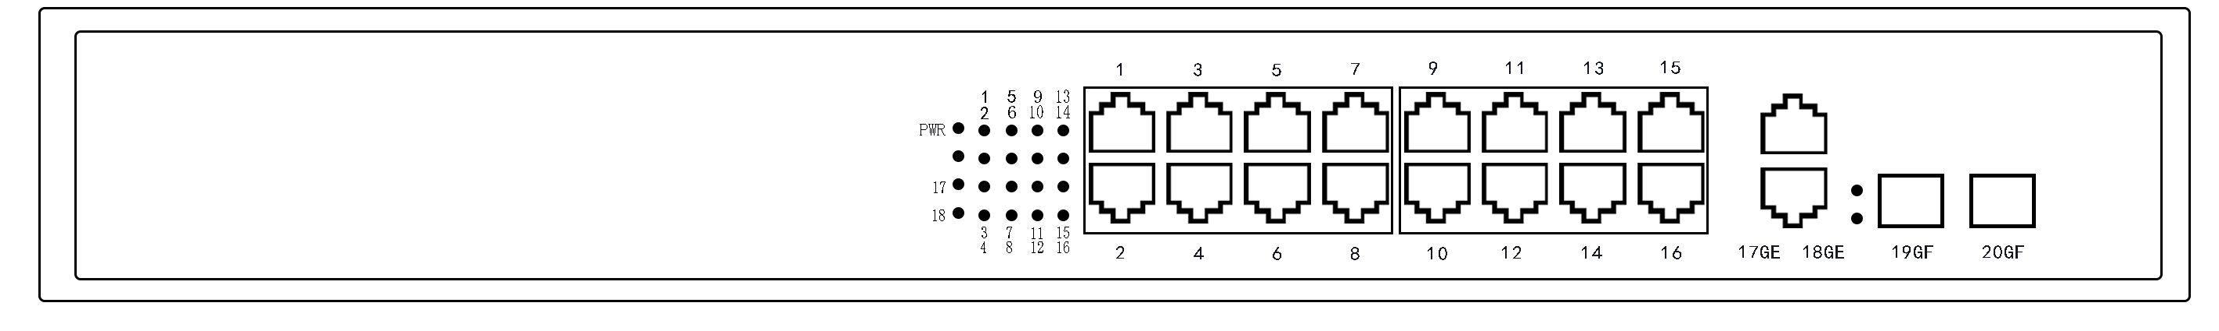 | 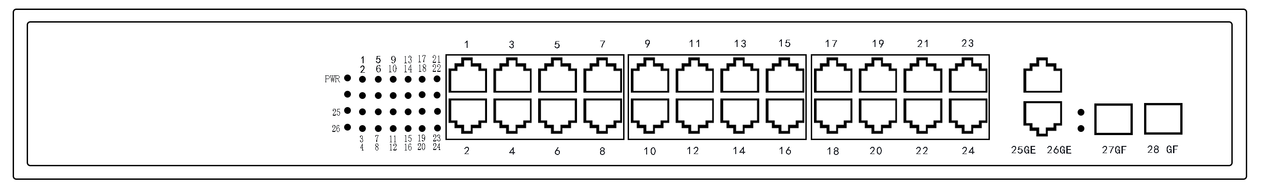
product name | Full 1000M 20 ports POE switch | Full 1000M 28 Ports POE switch
Total power | 200W 260W | 200W 260W 320W
UPLINK | 2*10/100/1000Mbps RJ45 ports +2*1.25G SFP Fiber ports
POE Port | 1-16 | 1-24
POE distance | 100m
Singl port power | 15.4W(16W)/25.5W(30W)
Power supply pin | 4 5 +/7 8-
data transmission | 1 2 +/3 6-
voltage range | AC220V / DC52V
Tempreature | -20℃~65℃
size | 430*295*45mm（1U Rack type）
Product panel diagram | 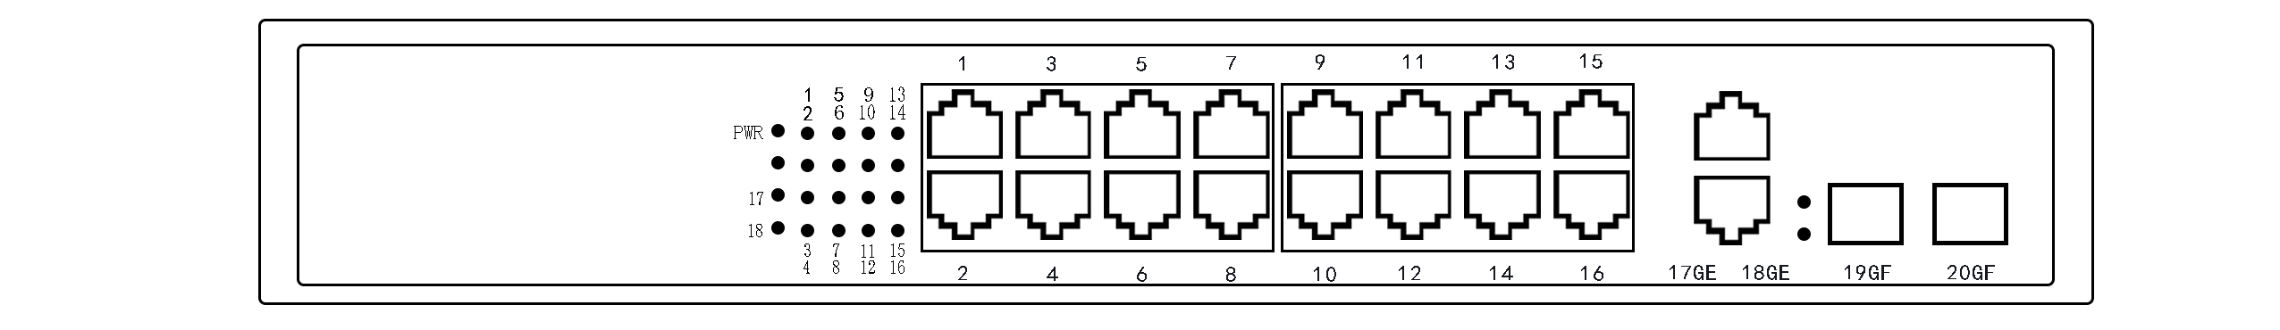 | 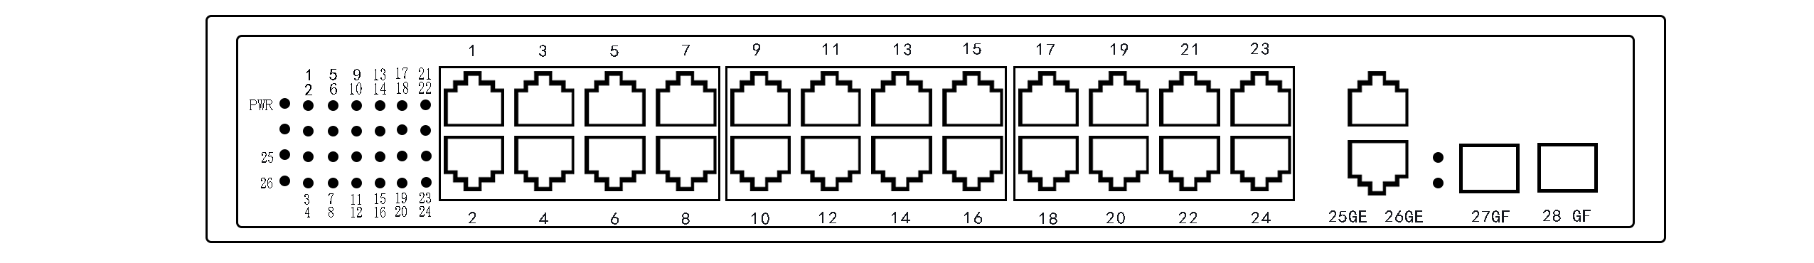
product name | Full 1000M 20 ports POE switch | Full 1000M 28 ports POE switch
Total power | 200W 260W | 200W 260W 320W
UPLINK | 2*10/100/1000Mbps RJ45 Ports +2*1.25G SFP Fiber ports
POE Port | 1-16 | 1-24
POE distance | 100m
Singl port power | 15.4W(16W)/25.5W(30W)
Power supply pin | 4 5 +/7 8-
data transmission | 1 2 +/3 6-
voltage range | AC220V / DC52V
Tempreature | -20℃~65℃
size | 310*182*45mm internal power supplyAC220V
LED indicator description

产品概述

Product panel diagram | 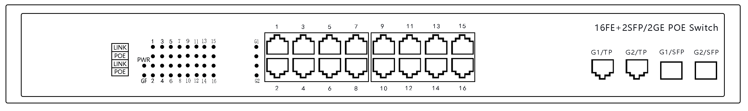 | 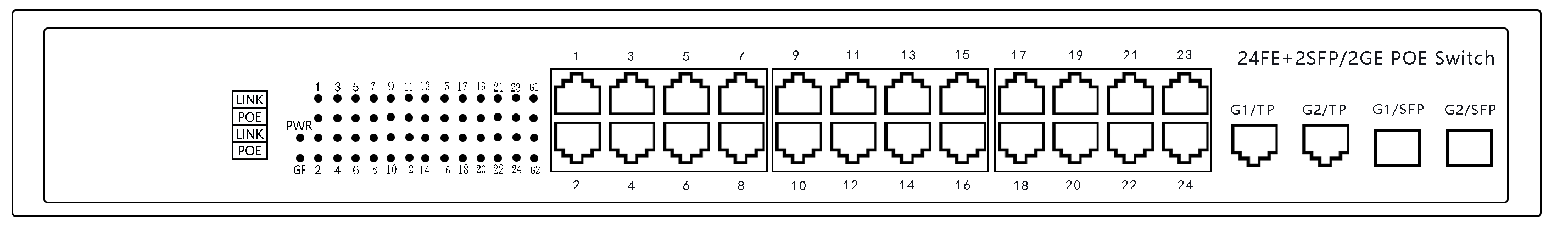
product name | 1000M 20 ports POE switch | 1000M 28 ports POE switch
Total power | 250W | 250W 380W
UPLINK | 2*10/100/1000Mbps RJ45 ports/2*1.25G SFP Fiber ports
POE Port | 1-16 | 1-24
POE distance | 100m
Singl port power | 15.4W(16W)/25.5W(30W)
Power supply pin | 1 2 +/3 6-
data transmission | 1 2 +/3 6-
voltage range | AC220V / DC52V
Tempreature | -20℃~65℃
size | 430*295*45mm（1U Rack type）

Application diagram

产品概述

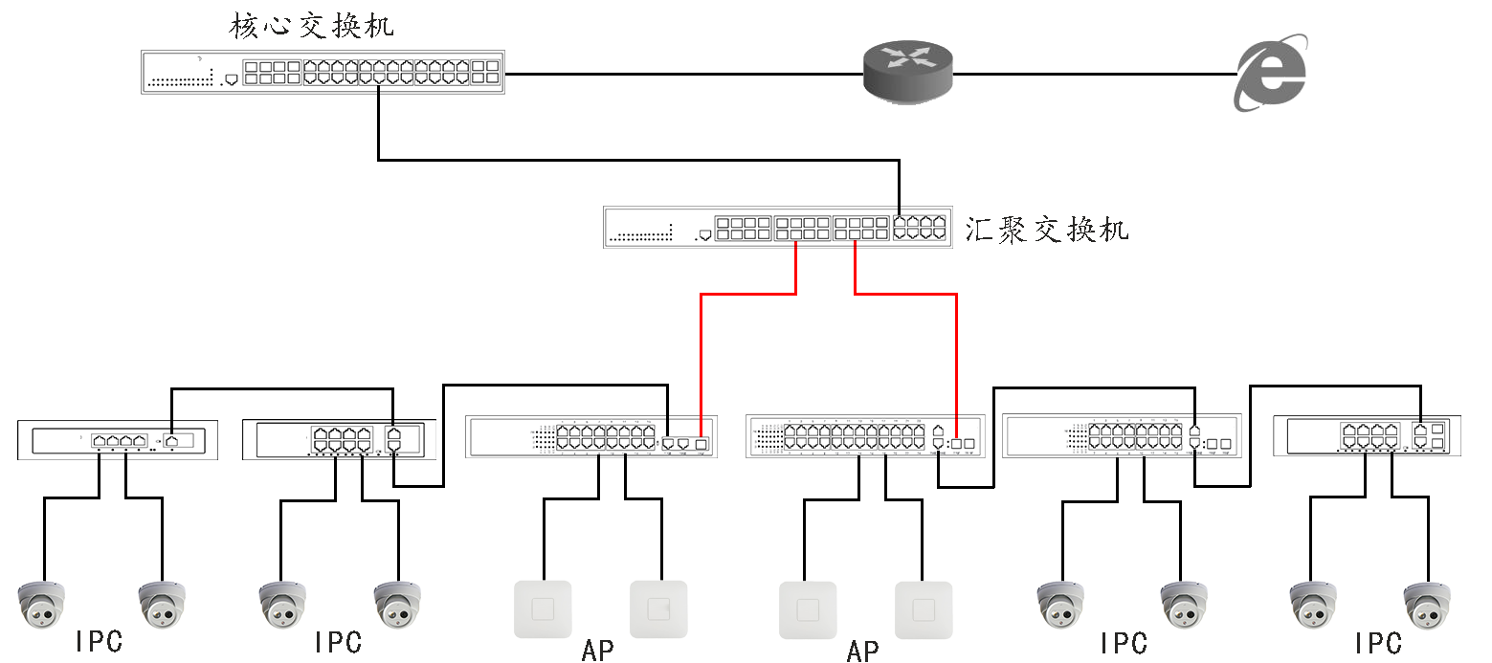

-8-

Indicator light | Color | Work status | Status description
Power  Indicator light | green | on | Equipment power supply is normal
Power  Indicator light | green | off | The device is not powered or the power supply is abnormal
Link/Act Indicator light | green | on | Connect to the network equipment normally
Link/Act Indicator light | green | flash | Data transmission, POE power supply synchronization
Link/Act Indicator light | green | off | Abnormal connection or device not connected
Reset Indicator light | green | on | 250m
Reset Indicator light | green | off | 100m

Item list diagram

产品概述

● POE switch 1pcs
● power cord 1pcs
● One copy each of user manual, warranty card, and certificate
1. When you encounter product questions, please call our engineers;
Service Hotline:: 400-8393-668
2. The final interpretation right of the content of this product description belongs to our company.

-9-
Item list产品概述

